W.D. Practical file

## EXPERIMENT 1- MAKING A CV USING HTML AND CSS.

Date:- 10/09/24

### Source Code:-

<!DOCTYPE html>

<html>

<head>

<title>Resume</title>

</head>

<body style="font-family: Arial, sans-serif; background-color: #f4f4f4; margin: 0; padding: 0; display: flex; justify-content: center; align-items: center; height: 100vh;">

<!-- Main Container with margins on left and right -->

<div style="background-color: #ffffff; width: 800px; padding: 40px; box-shadow: 0 0 15px rgba(0,0,0,0.1);">

<!-- Header with Personal Details and Photo -->

<div style="display: flex; justify-content: space-between; align-items: center; border-bottom: 2px solid #333; padding-bottom: 10px;">

<div style="width: 65%;">

<h1 style="margin: 0;">Ritika</h1>

<p style="margin: 5px 0;"><strong>Email:</strong> ritikaraghav@gmail.com</p>

<p style="margin: 5px 0;"><strong>Second Email:</strong> Ritika.raghav@outlook.com</p>

<p style="margin: 5px 0;"><strong>Phone:</strong> +91-98XXXXXX19</p>

</div>

<div style="width: 30%; text-align: right;">

<img src="Myphoto.png" alt="Your Photo" style="border-radius: 50%; width: 150px; height: 150px;">

</div>

</div>

<!-- About -->

<div>

<section style="margin-top: 20px;">

<h2 style="margin-bottom: 10px;">About</h2>

<p>As a dedicated B.Tech CSE student, I am passionate about exploring the vast world of technology and its applications. My current academic journey has equipped me with a strong foundation in programming, particularly in C and C++.</p>

</section>

</div>

<!-- Skills Section -->

<section style="margin-top: 20px;">

<h2 style="margin-bottom: 10px;">Skills</h2>

<ul style="list-style-type: disc; padding-left: 20px;">

<li>C++</li>

<li>Python</li>

<li>HTML</li>

<li>Data Structures & Algorithms</li>

<li>Competitive Coding</li>

</ul>

</section>

<!-- Technical Profeciencies -->

<section style="margin-top: 20px;">

<h2 style="margin-bottom: 10px;">Technical Profeciencies</h2>

<dl>

<dt>

Version Control

</dt>

<dd>

Git / GitHub

</dd>

<dt>

Database Management

</dt>

<dd>

MySQL

CSV and text file handling

</dd>

<dt>

Tools and IDEs

</dt>

<dd>

Visual Studio Code

PyCharm

</dd>

</dl>

</section>

<!-- Education Section -->

<section style="margin-top: 20px;">

<h2 style="margin-bottom: 10px;">Education</h2>

<table border="5px">

<tr>

<th>Course</th>

<th>University</th>

<th>Year of Passing</th>

<th>Percentage/C.G.P.A</th>

</tr>

<tr>

<td>B.Tech.(C.S.E.)</td>

<td>Inderprastha Engineering College, Vaishali Ghaziabad</td>

<td>2027</td>

<td>8.2</td>

</tr>

<tr>

<td>12th</td>

<td>Laxmi Public School, Laxmi Nagar</td>

<td>2023</td>

<td>91</td>

</tr>

<tr>

<td>10th</td>

<td>Laxmi Public School, Laxmi Nagar</td>

<td>2021</td>

<td>94</td>

</tr>

</table>

</section>

<!-- Experience -->

<section style="margin-top: 20px;">

<h2 style="margin-bottom: 10px;">Experience</h2>

<dl>

<dt>

Google Internship (Junior Data Analyst)

</dt>

<dd>

Nov 20XX - Jan 20XX (3 month)

</dd>

<dt>

Microsoft Internship (Junior Web Developer)

</dt>

<dd>

April 20XX - Oct 20XX (6 month)

</dd>

</dl>

</section>

<!-- Certifications and Qualifications Section -->

<section style="margin-top: 20px;">

<h2 style="margin-bottom: 10px;">Certifications and Qualifications</h2>

<ul style="list-style-type: disc; padding-left: 20px;">

<li>NPTEL Certification - Completed</li>

<li>C++ Certification - Great Learning</li>

</ul>

</section>

<!-- Awards Section -->

<section style="margin-top: 20px;">

<h2 style="margin-bottom: 10px;">Awards</h2>

<ul style="list-style-type: disc; padding-left: 20px;">

<li>2st position in Code Combat Competition by ACM Student Chapter Society</li>

<li>2nd position in Ideathon by Think AI Club</li>

</ul>

</section>

<!-- Hobbies and Interests Section -->

<section style="margin-top: 20px;">

<h2 style="margin-bottom: 10px;">Hobbies and Interests</h2>

<ul style="list-style-type: disc; padding-left: 20px;">

<li>Exploring AI, Machine Learning, and Full-Stack Development</li>

<li>Participating in Competitive Coding Competitions</li>

</ul>

</section>

<!-- Personal Details Section -->

<section style="margin-top: 20px;">

<h2 style="margin-bottom: 10px;">Personal Derails</h2>

<ul style="list-style-type: disc; padding-left: 20px;">

<li>

<p style="margin: 5px 0;"><strong>Address:</strong> Laxmi Nagar, East Delhi, 110092</p>

</li>

<li>

<p style="margin: 5px 0;"><strong>GitHub:</strong> <a href="https://github.com/RitikaRaghav" target="_blank">github.com/RitikaRaghav </a></p>

</li>

<li>

<p style="margin: 5px 0;"><strong>LinkedIn:</strong> <a href="https://www.linkedin.com/in/RitikaRaghav " target="_blank">linkedin.com/in/RitikaRaghav </a></p>

</li>

</ul>

</section>

</div>

</body>

</html>

### Output:--

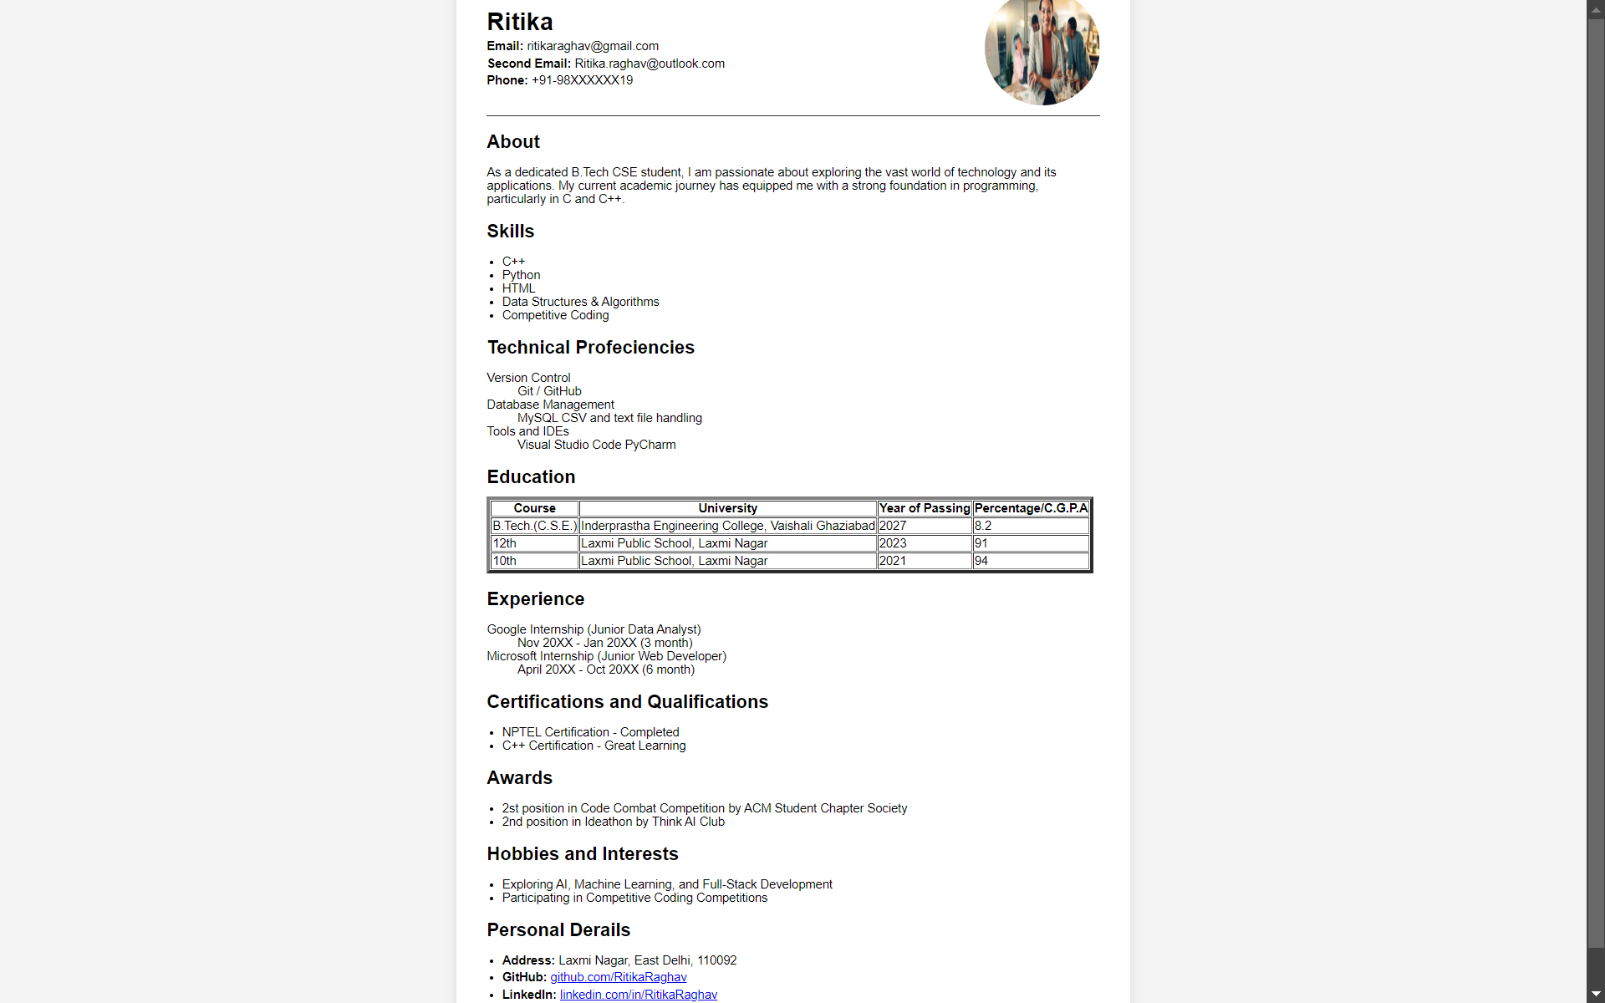

## EXPERIMENT 2- TO MAKE A STUDENT REGISTRATION FORM.

Date:- 17/09/24

### Source Code:-

Registration Form

<!DOCTYPE html>

<html lang="en">

<head>

<meta charset="UTF-8">

<meta name="viewport" content="width=device-width, initial-scale=1.0">

<title>Registration Form</title>

</head>

<body style="background-color: #FFF5E1; font-size: large; display: flex; justify-content: center; align-items: center; height: 100vh; margin: 0;">

<div style="background-color: #FFFFFF; padding: 20px; border: 2px solid #333; border-radius: 8px; width: 50%; box-shadow: 0px 0px 10px rgba(0, 0, 0, 0.1);">

<h2 style="text-align: center; color: #333;">Registration Form</h2>

<form action="Submit.html" style="display: flex; flex-direction: column; gap: 15px;">

<div style="display: flex; flex-direction: column;">

<label>First Name</label>

<input type="text" name="First_Name" required style="width: 100%; height: 30px; padding: 5px; border: 1px solid #ccc; border-radius: 4px;">

</div>

<div style="display: flex; flex-direction: column;">

<label>Last Name</label>

<input type="text" name="Last_Name" style="width: 100%; height: 30px; padding: 5px; border: 1px solid #ccc; border-radius: 4px;">

</div>

<div style="display: flex; flex-direction: column;">

<label>Date of Birth</label>

<input type="date" name="Date_of_Birth" style="width: 100%; height: 30px; padding: 5px; border: 1px solid #ccc; border-radius: 4px;">

</div>

<!-- Gender section -->

<div>

<label>Gender</label><br>

<input type="radio" name="Gender" value="Male"> Male

<input type="radio" name="Gender" value="Female"> Female

<input type="radio" name="Gender" value="Other"> Other

</div>

<div style="display: flex; flex-direction: column;">

<label>E-Mail Id</label>

<input type="email" name="E-Mail" required style="width: 100%; height: 30px; padding: 5px; border: 1px solid #ccc; border-radius: 4px;">

</div>

<div style="display: flex; flex-direction: column;">

<label>Mobile Number</label>

<input type="number" name="Mobile_Number" required style="width: 100%; height: 30px; padding: 5px; border: 1px solid #ccc; border-radius: 4px;">

</div>

<div style="display: flex; flex-direction: column;">

<label>Address</label>

<input type="text" name="Address" style="width: 100%; height: 30px; padding: 5px; border: 1px solid #ccc; border-radius: 4px;">

</div>

<!-- Course dropdown -->

<div style="display: flex; flex-direction: column;">

<label>Course</label>

<select name="Course" style="width: 100%; height: 35px; padding: 5px; border: 1px solid #ccc; border-radius: 4px;">

<option value="B.Tech.">B.Tech.</option>

<option value="B.B.A">B.B.A</option>

<option value="B.Sc.">B.Sc.</option>

<option value="M.C.A">M.C.A</option>

</select>

</div>

<!-- Board dropdown -->

<div style="display: flex; flex-direction: column;">

<label>Board</label>

<select name="Board" style="width: 100%; height: 35px; padding: 5px; border: 1px solid #ccc; border-radius: 4px;">

<option value="C.B.S.E">C.B.S.E.</option>

<option value="I.C.S.C.">I.C.S.C.</option>

<option value="State Board">State Board</option>

</select>

</div>

<div style="display: flex; flex-direction: column;">

<label>Marks in Percentage</label>

<input type="number" name="marks" style="width: 100%; height: 30px; padding: 5px; border: 1px solid #ccc; border-radius: 4px;">

</div>

<!-- Category section -->

<div>

<label>Category</label><br>

<input type="radio" name="Category" value="General"> General

<input type="radio" name="Category" value="S.C."> S.C.

<input type="radio" name="Category" value="S.T."> S.T.

<input type="radio" name="Category" value="O.B.C."> O.B.C.

<input type="radio" name="Category" value="General-EWS"> General-EWS

</div>

<!-- Sports section -->

<div>

<label>Sports/Co-Curricular Activities</label><br>

<input type="checkbox" name="Cricket" value="Cricket"> Cricket

<input type="checkbox" name="Football" value="Football"> Football

<input type="checkbox" name="Badminton" value="Badminton"> Badminton

<input type="checkbox" name="Basketball" value="Basketball"> Basketball

<input type="checkbox" name="Table Tennis" value="Table Tennis"> Table Tennis

<input type="checkbox" name="Chess" value="Chess"> Chess

<input type="checkbox" name="Kho-Kho" value="Kho-Kho"> Kho-Kho

<input type="checkbox" name="Kabaddi" value="Kabaddi"> Kabaddi

</div>

<!-- File and Password -->

<div style="display: flex; flex-direction: column;">

<label>12 Mark Sheet</label>

<input type="file" name="12_Mark_Sheet" style="width: 100%; padding: 5px; border: 1px solid #ccc; border-radius: 4px;">

</div>

<div style="display: flex; flex-direction: column;">

<label>Password</label>

<input type="password" name="Password" style="width: 100%; height: 30px; padding: 5px; border: 1px solid #ccc; border-radius: 4px;">

</div>

<!-- Submit and Reset buttons -->

<div style="display: flex; justify-content: center; gap: 20px;">

<input type="submit" value="Submit" style="width: 100px; height: 35px; background-color: #4CAF50; color: white; border: none; border-radius: 4px;">

<input type="reset" value="Reset" style="width: 100px; height: 35px; background-color: #f44336; color: white; border: none; border-radius: 4px;">

</div>

</form>

</div>

</body>

</html>

Submission Page

<!DOCTYPE html>

<html lang="en">

<head>

<meta charset="UTF-8">

<meta name="viewport" content="width=device-width, initial-scale=1.0">

<title>Submit</title>

</head>

<body style="background-color: lightgreen; text-align: center; padding: 50px; font-size: xx-large;">

<h1>Thank You!</h1>

<p>Your submission has been received.</p>

<p>We will get back to you soon.</p>

<a href="form.html" style="font-size: 20px; color: blue; text-decoration: none;">Return to Form</a>

</body>

</html>

### Output:--

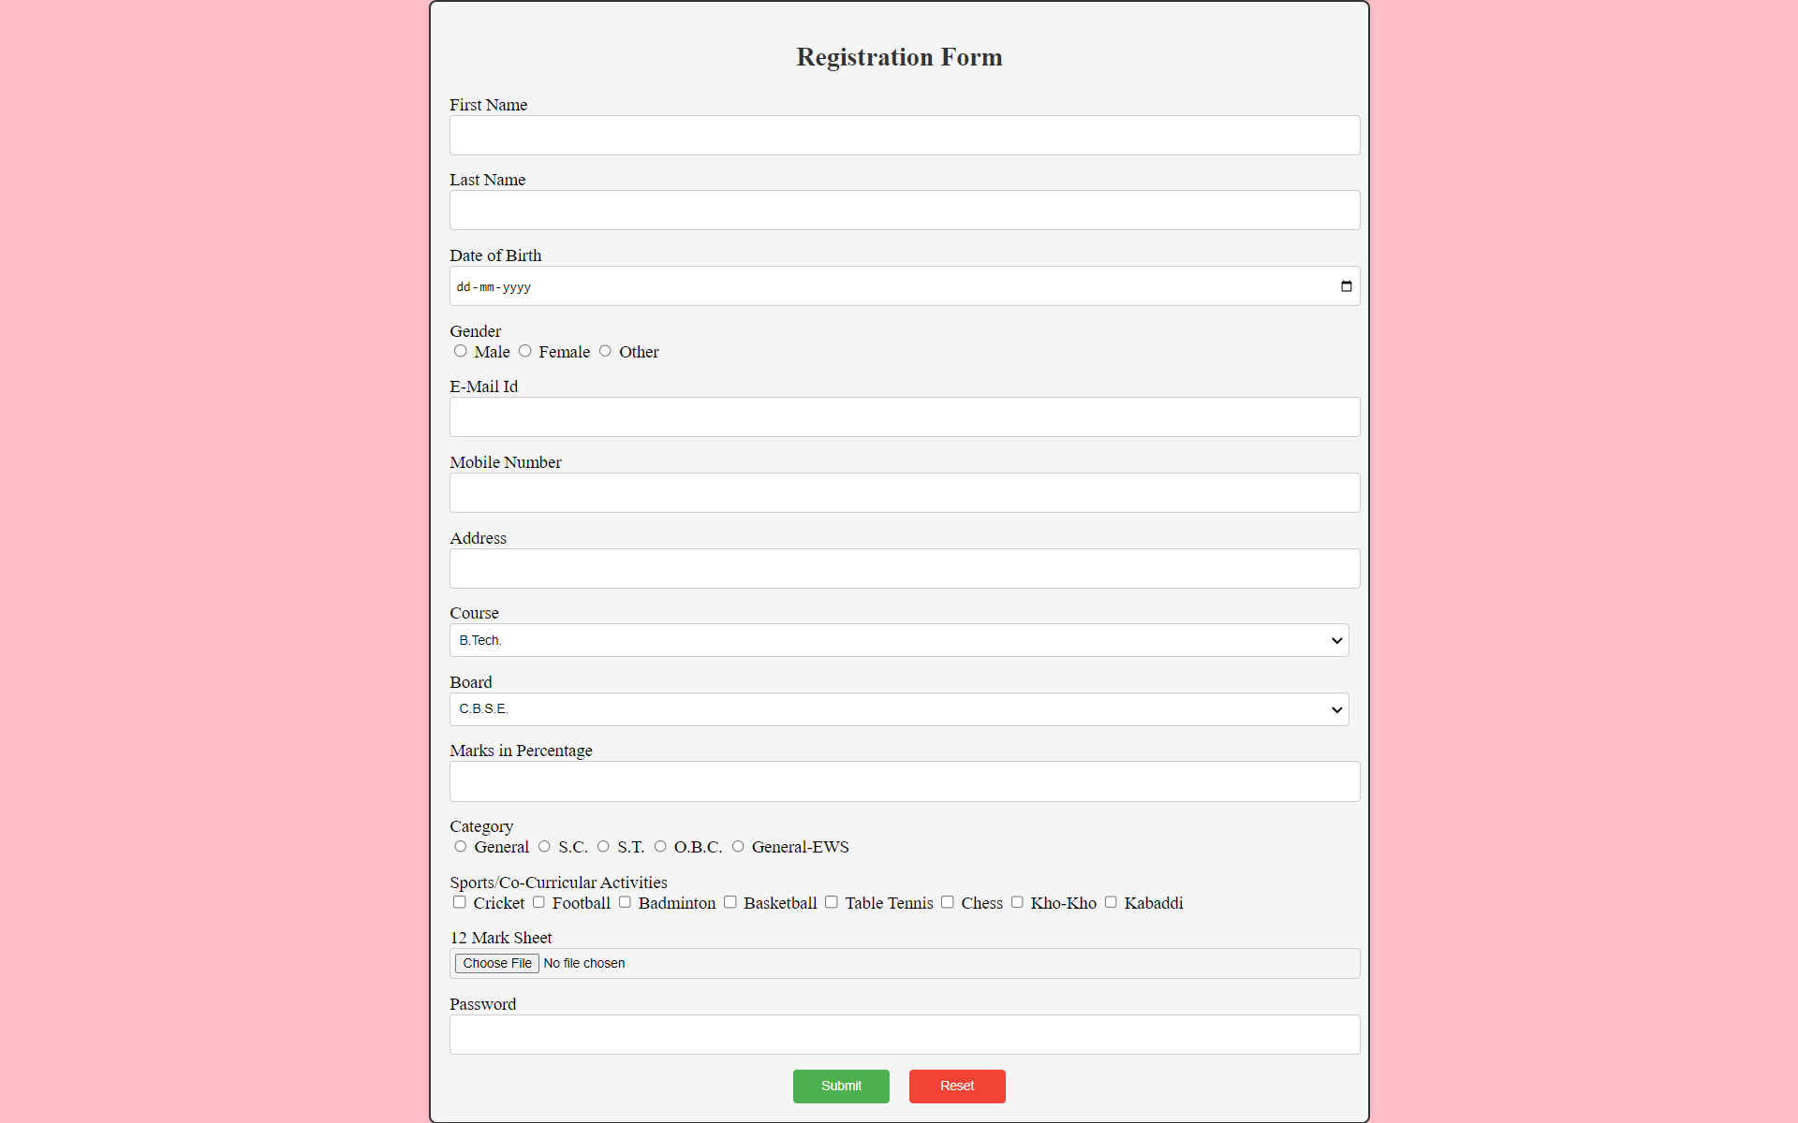

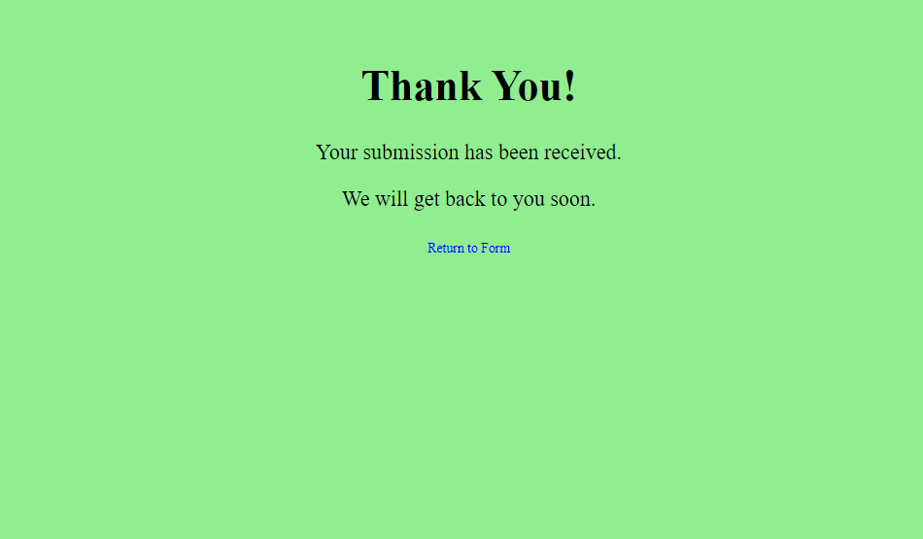

## EXPERIMENT 3:- MAKE A HOMEPAGE FOR COLLEGE WEBSITE.

Date:- 24/09/24

### Source Code:--

Main.html

<!DOCTYPE html>

<html lang="en">

<head>

<meta charset="UTF-8">

<meta name="viewport" content="width=device-width, initial-scale=1.0">

<title>Take 03- Main</title>

</head>

<frameset rows="16%, *">

<frame name="topleftFrame" src="topframe.html">

<frameset cols="14%, *">

<frame name="BottomLeftFrame" src="bottomleft.html">

<frame name="bottomRightFrame" src="bottomright.html" >

</frameset>

</frameset>

</html>

topframe.html

<!DOCTYPE html>

<html lang="en">

<head>

<meta charset="UTF-8">

<meta name="viewport" content="width=device-width, initial-scale=1.0">

<title>Top 1 Frame</title>

<link rel="stylesheet" href="topframe.css">

</head>

<body style="background: linear-gradient(to right, #3498db, #2980b9);">

<header>

<div>

<div class="logo-container">

<img src="Images/ipec_logo.jpg" alt="College Logo" class="logo" height="100" width="100" >

<h1 class="college-name">Inderprastha Engineering College</h1>

</div>

<nav>

<ul>

<li><a href="home.html" target="bottomRightFrame">Home</a></li>

<li><a href="login_page.html" target="bottomRightFrame">Login</a></li>

<li><a href="RegistrationForm.html" target="bottomRightFrame">Registration</a></li>

<li><a href="catalouge.html" target="bottomRightFrame">Catalogue</a></li>

</ul>

</nav>

</div>

</header>

</body>

</html>

topframe.css

.logo-container {

display: flex;

align-items: center;

gap: 0px;

padding: 20px; /* Add padding for spacing */

border-bottom: 2px solid #ccc; /* Add a bottom border */

}

.college-name {

flex-grow: 1;

text-align: center;

font-size: 44px; /* Adjust font size as needed */

font-weight: bold; /* Add bold font weight */

color: #fff; /* Set text color to white */

}

nav ul {

display: flex;

list-style: none;

margin: 0;

padding: 0;

justify-content: flex-end;

align-items: center;

}

nav li {

margin-right: 50px; /* Adjust spacing between links */

}

nav a {

color: #fff;

text-decoration: none;

font-weight: bold;

}

nav a:hover {

color: red

}

nav a:active {

color: greenyellow

}

bottomleft.html

<!DOCTYPE html>

<html lang="en">

<head>

<meta charset="UTF-8">

<meta name="viewport" content="width=device-width, initial-scale=1.0">

<title>Bottom Left Frame</title>

<link rel="stylesheet" href="bottomleft.css">

</head>

<body>

<div class="main-container">

<aside class="sidebar">

<h3>Engineering Subjects</h3>

<ul>

<li><a href="#">Computer Science</a></li>

<li><a href="#">Mechanical Engineering</a></li>

<li><a href="#">Electrical Engineering</a></li>

<li><a href="#">Civil Engineering</a></li>

<li><a href="#">BioTechnical Engineering</a></li>

</ul>

</aside>

</div>

</body>

</html>

bottomleft.css

body {

margin: 0;

font-family: Arial, sans-serif;

background: #3498db;

}

.main-container {

display: flex;

height: 100vh;

}

.sidebar {

background-color: #2a8ef9;

color: white;

padding: 20px;

width: 250px;

}

.sidebar h3 {

margin-bottom: 20px;

}

.sidebar ul {

list-style-type: none;

padding: 0;

}

.sidebar li {

margin-bottom: 15px;

}

.sidebar a {

color: white;

text-decoration: none;

display: block;

padding: 10px;

border: none;

background-color: #1a73d9;

border-radius: 5px;

width: 100%;

text-align: left;

}

.sidebar a:hover {

background-color: #007bff;

}

home.html

<!DOCTYPE html>

<html lang="en">

<head>

<meta charset="UTF-8">

<meta name="viewport" content="width=device-width, initial-scale=1.0">

<title>Home Page</title>

<link rel="stylesheet" href="home.css">

</head>

<body>

<div class="main-container">

<!-- Welcome Section -->

<div class="content" align="center">

<section class="welcome-section">

<h1>Welcome to <span class="highlight">IPEC Bookstore</span></h1>

<p>Your one-stop shop for all your academic book needs!</p>

</section>

<!-- Search Bar -->

<section class="search-bar">

<input type="text" placeholder="Search for books, authors, or ISBN...">

<button>Search</button>

</section>

</div>

<!-- Stats Section -->

<div class="stats">

<div class="stat">

<p class="number">20+</p>

<p>Years of Excellence</p>

</div>

<div class="stat">

<p class="number">15000+</p>

<p>Alumni</p>

</div>

<div class="stat">

<p class="number">200+</p>

<p>Recruiters</p>

</div>

<div class="stat">

<p class="number">100+</p>

<p>Awards Won</p>

</div>

</div>

<!-- About Section -->

<section class="about">

<p>IPEC is one of the most preferred engineering colleges in Ghaziabad Delhi NCR for aspiring engineers and technologists.</p>

<p>It was established in the year 2000, by leading academicians and business leaders in North India, under the aegis of Shail Garg Shiksha Sansthan, a non-profit making society. IPEC is the best engineering college in Ghaziabad Delhi NCR with 20+ years of excellence, a rich alumni base of 15000+ students, and best placement with 200+ recruiters.</p>

<a href="#" class="view-more-btn">View More</a>

</section>

<!-- Accreditations Section -->

<section class="accreditations">

<img src="Images/AICTC_logo.webp" alt="AICTE" width="100">

<img src="Images/aktu_logo.jpg" alt="AKTU" width="100">

<img src="Images/NBA_logo.jpeg" alt="NBA" width="100">

<img src="Images/naac.jpeg" alt="NAAC" width="100">

</section>

</div>

<!-- Footer -->

<footer>

<hr>

<section class="assistance" align="center">

<h2>Need Assistance?</h2>

<p>Our team is here to help you find the right books for your courses.</p>

<button class="contact-btn">Contact Support</button>

</section>

</footer>

</body>

</html>

home.css

body {

font-family: Arial, sans-serif;

margin: 0;

padding: 0;

background: linear-gradient(to bottom, #f7f9fc, #e8eef3);

color: #333;

}

header {

background-color: #2a8ef9;

color: white;

padding: 1rem;

display: flex;

justify-content: space-between;

align-items: center;

}

.logo-container {

background: linear-gradient(to right, #3498db, #2980b9);

display: flex;

align-items: center;

}

.logo {

width: 50px;

height: 50px;

margin-right: 1rem;

text-align: center;

}

.college-name {

font-size: 1.5rem;

font-weight: bold;

}

.sidebar {

width: 250px;

background-color: #ffffff;

padding: 2rem 1rem;

box-shadow: 2px 0 10px rgba(0, 0, 0, 0.1);

}

.stats {

display: flex;

justify-content: space-around;

margin: 20px;

text-align: center;

}

.stat {

background: #ecf0f1;

padding: 20px;

border-radius: 10px;

width: 20%;

box-shadow: 0 4px 6px rgba(0, 0, 0, 0.1);

transition: transform 0.3s;

}

.stat:hover {

transform: scale(1.05);

}

.number {

font-size: 2em;

font-weight: bold;

color: #e74c3c;

}

.about {

margin: 30px;

padding: 20px;

background: #fff;

border-radius: 10px;

box-shadow: 0 4px 6px rgba(0, 0, 0, 0.1);

}

.view-more-btn {

display: inline-block;

margin-top: 10px;

padding: 10px 20px;

background: #3498db;

color: #fff;

text-decoration: none;

border-radius: 5px;

transition: background-color 0.3s;

}

.view-more-btn:hover {

background: #2980b9;

}

.updates {

display: flex;

flex-wrap: wrap;

justify-content: space-between;

padding: 20px;

}

.update {

background-color: #f0f0f0;

padding: 20px;

margin-bottom: 20px;

}

.accreditations {

text-align: center;

margin: 20px;

}

.accreditations img {

margin: 10px;

transition: transform 0.3s;

}

.accreditations img:hover {

transform: scale(1.1);

}

.highlight {

color: #e74c3c;

}

.welcome-section {

padding: 20px;

background: linear-gradient(to right, #3498db, #2980b9);

color: #fff;

border-radius: 10px;

margin: 20px;

text-align: center;

}

.search-bar {

margin: 20px 0;

}

.search-bar input {

padding: 10px;

width: 50%;

border: 1px solid #ddd;

border-radius: 5px;

font-size: 1em;

}

.search-bar button {

padding: 10px 20px;

font-size: 1em;

border: none;

background-color: #3498db;

color: white;

cursor: pointer;

border-radius: 5px;

margin-left: 10px;

transition: background-color 0.3s;

}

.search-bar button:hover {

background-color: #2980b9;

}

footer {

background: #34495e;

color: #ecf0f1;

padding: 20px 0;

text-align: center;

}

footer h2 {

margin-bottom: 10px;

}

.contact-btn {

padding: 10px 20px;

background: #e74c3c;

color: white;

border: none;

border-radius: 5px;

cursor: pointer;

transition: background-color 0.3s;

}

.contact-btn:hover {

background: #c0392b; 1

}

### Output:-

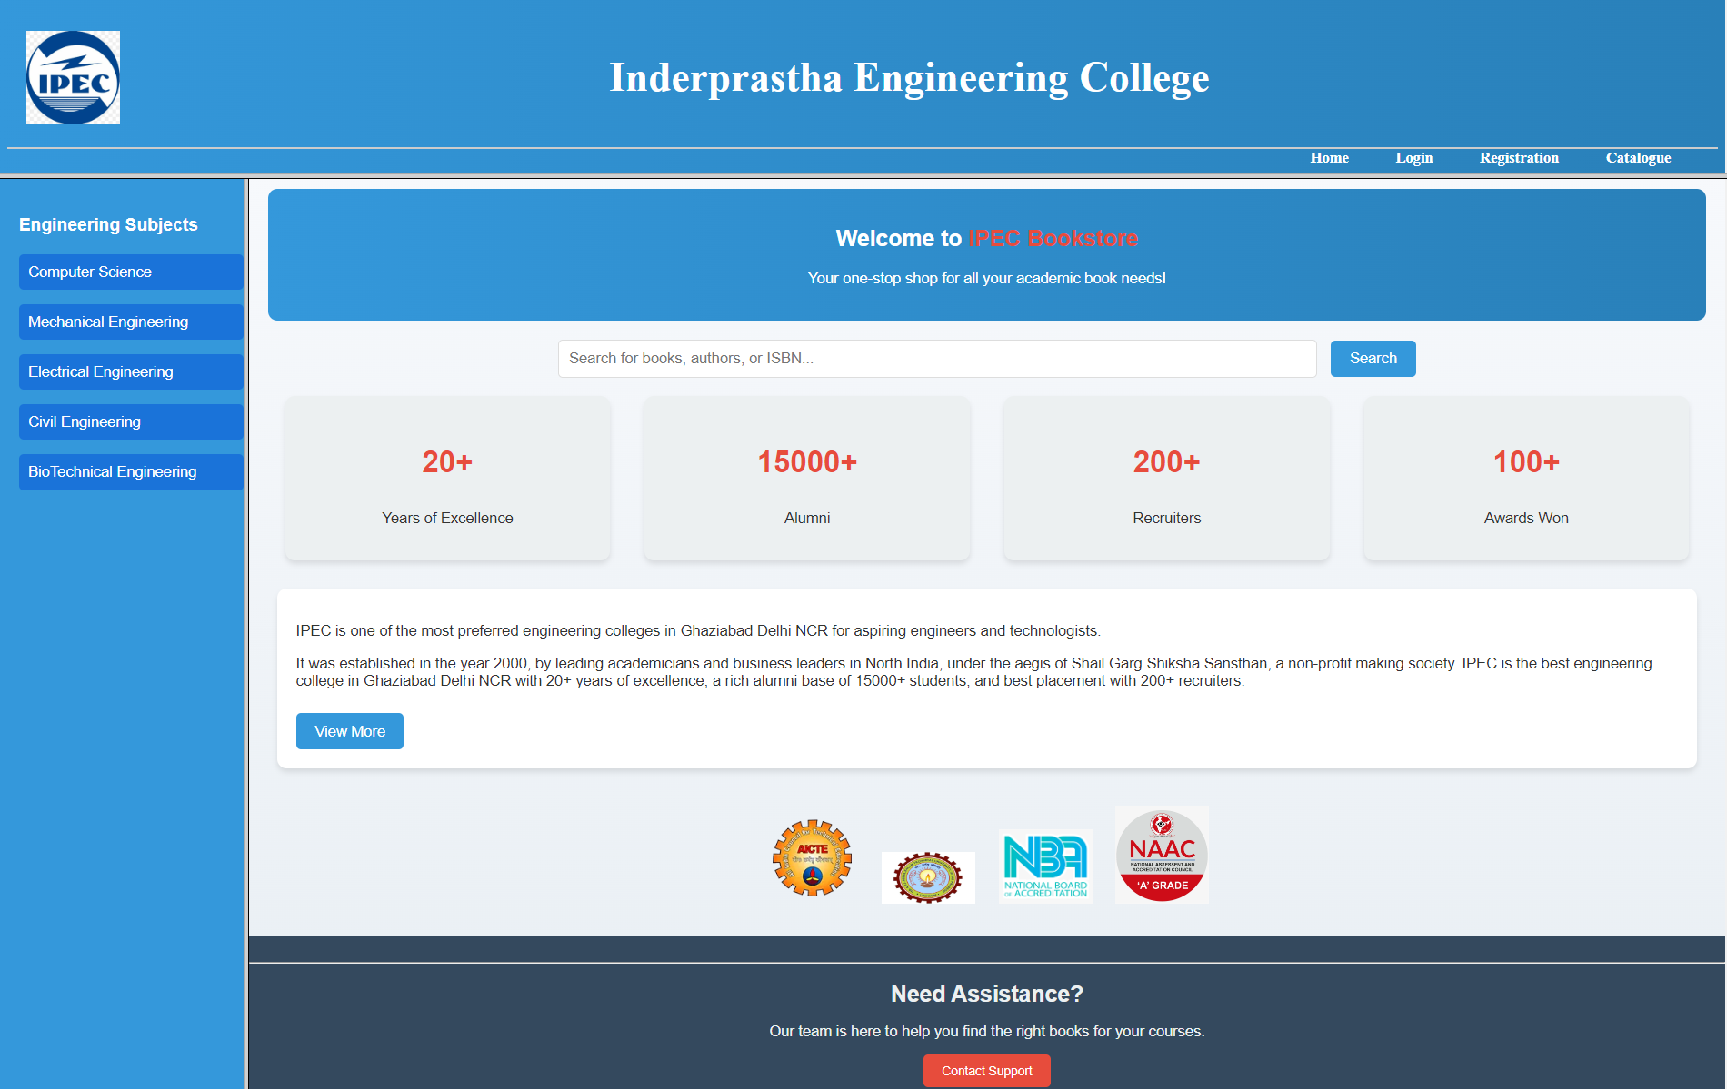

### 

## EXPERIMENT 4:- MAKE A LOGIN PAGE FOR COLLEGE WEBSITE.

Date:- 01/10/24

### Source Code:--

Login.html

<!DOCTYPE html>

<html lang="en">

<head>

<meta charset="UTF-8">

<meta name="viewport" content="width=device-width, initial-scale=1.0">

<title>Login Page</title>

<link rel="stylesheet" href="login.css">

</head>

<body>

<div class="login-container">

<h2>Login</h2>

<form action="dashboard.html" method="post">

<label for="student-id">Student ID:</label>

<input type="text" id="student-id" name="student-id" required>

<label for="password">Password:</label>

<input type="password" id="password" name="password" required>

<button type="submit">Login</button>

<a href="#">Forgot Password?</a>

</form>

</div>

</body>

</html>

Login.css

body {

font-family: Arial, sans-serif;

background-color: #3498db;

display: flex;

justify-content: center;

align-items: center;

height: 100vh;

margin: 0;

}

.login-container {

background-color: #fff;

padding: 40px;

border-radius: 10px;

box-shadow: 0px 0px 10px rgba(0, 0, 0, 0.2);

width: 350px;

}

h2 {

text-align: center;

margin-bottom: 20px;

font-size: 24px;

}

form {

text-align: center;

}

label {

display: block;

margin-bottom: 10px;

font-weight: bold;

}

input {

width: 100%;

padding: 10px;

margin-bottom: 20px;

border: 1px solid #ccc;

border-radius: 5px;

}

button {

background-color: #3498db;

color: white;

padding: 10px 20px;

border: none;

border-radius: 5px;

cursor: pointer;

}

a {

color: #3498db;

text-decoration: none;

}

### Output:-

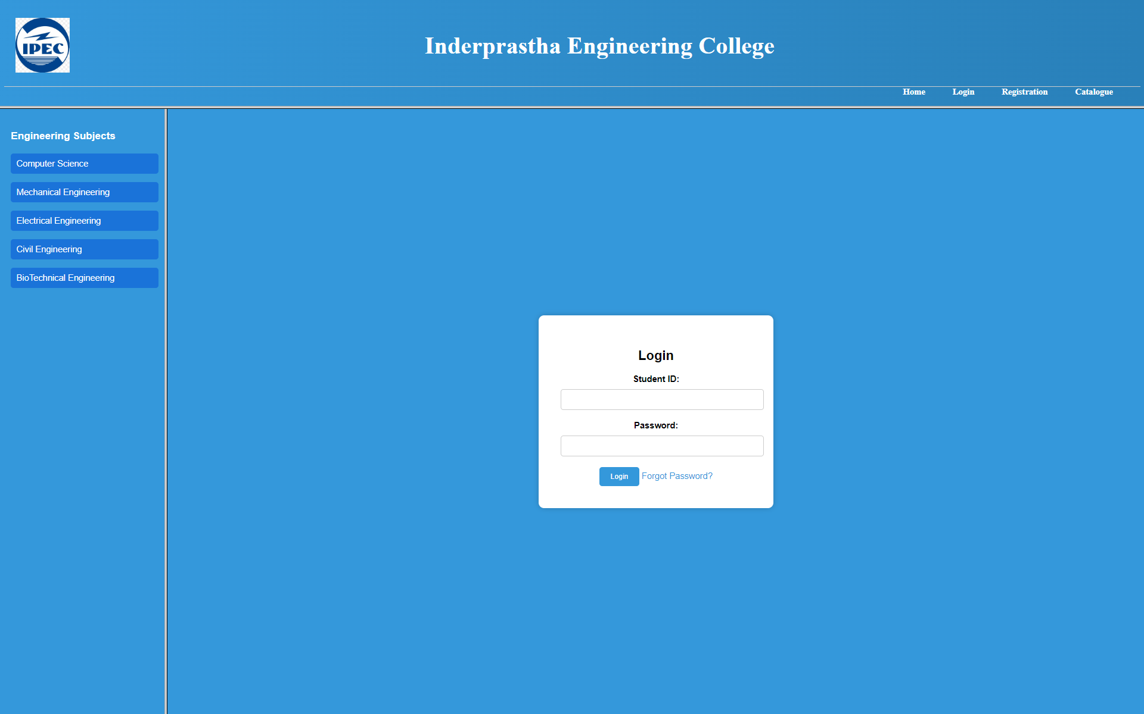

## EXPERIMENT 5:- MAKE A CATALOGUE PAGE FOR COLLEGE WEBSITE.

Date:- 08/10/24

### Source Code:--

Catalogue.html

<!DOCTYPE html>

<html lang="en">

<head>

<meta charset="UTF-8">

<meta name="viewport" content="width=device-width, initial-scale=1.0">

<title>Catalogue</title>

<link rel="stylesheet" href="catalogue.css">

</head>

<body>

<div class="catalogue-container">

<header class="header">

<h1>Book Catalogue</h1>

<p>Explore our collection of academic books!</p>

</header>

<div class="book-container">

<div class="book-item">

<img src="Images/DS_c_cpp.jpeg" alt="Data Structures and Algorithms">

<div class="book-details">

<h3>DS and C++</h3>

<p><strong>Author:</strong> Yedidyaah Langsam</p>

<p><strong>Publication:</strong> Wiley</p>

<p><strong>Price:</strong> Rs. 1099</p>

</div>

<button class="add-to-cart">Add to Cart</button>

</div>

<div class="book-item">

<img src="Images/EE.jpg" alt="Electrical Engineering">

<div class="book-details">

<h3>Electrical Engineering</h3>

<p><strong>Author:</strong> K.S. Suresh Kumar</p>

<p><strong>Publication:</strong> Princetonhall</p>

<p><strong>Price:</strong> Rs. 1899</p>

</div>

<button class="add-to-cart">Add to Cart</button>

</div>

<div class="book-item">

<img src="Images/FluidD.jpeg" alt="Fluid Mechanics">

<div class="book-details">

<h3>Fluid Mechanics</h3>

<p><strong>Author:</strong> Yedidyaah Langsam</p>

<p><strong>Publication:</strong> Wiley</p>

<p><strong>Price:</strong> Rs. 1099</p>

</div>

<button class="add-to-cart">Add to Cart</button>

</div>

<div class="book-item">

<img src="Images/Intro_Algo.jpeg" alt="Algorithms">

<div class="book-details">

<h3>Algorithms</h3>

<p><strong>Author:</strong> Yedidyaah Langsam</p>

<p><strong>Publication:</strong> Wiley</p>

<p><strong>Price:</strong> Rs. 1099</p>

</div>

<button class="add-to-cart">Add to Cart</button>

</div>

<div class="book-item">

<img src="Images/ME.jpeg" alt="Mechanics">

<div class="book-details">

<h3>Mechanical Engineering</h3>

<p><strong>Author:</strong> Yedidyaah Langsam</p>

<p><strong>Publication:</strong> Wiley</p>

<p><strong>Price:</strong> Rs. 1099</p>

</div>

<button class="add-to-cart">Add to Cart</button>

</div>

<div class="book-item">

<img src="Images/MechMat.jpg" alt="Mechanics of Materials">

<div class="book-details">

<h3>Mechanics of Materials</h3>

<p><strong>Author:</strong> Yedidyaah Langsam</p>

<p><strong>Publication:</strong> Wiley</p>

<p><strong>Price:</strong> Rs. 1099</p>

</div>

<button class="add-to-cart">Add to Cart</button>

</div>

<div class="book-item">

<img src="Images/StructAnal.jpg" alt="Structural Analysis">

<div class="book-details">

<h3>Structural Analysis</h3>

<p><strong>Author:</strong> Yedidyaah Langsam</p>

<p><strong>Publication:</strong> Wiley</p>

<p><strong>Price:</strong> Rs. 1099</p>

</div>

<button class="add-to-cart">Add to Cart</button>

</div>

<div class="book-item">

<img src="Images/SysCtrl_.jpg" alt="System Control">

<div class="book-details">

<h3>System Control</h3>

<p><strong>Author:</strong> Yedidyaah Langsam</p>

<p><strong>Publication:</strong> Wiley</p>

<p><strong>Price:</strong> Rs. 1099</p>

</div>

<button class="add-to-cart">Add to Cart</button>

</div>

<div class="book-item">

<img src="Images/thermo.jpg" alt="Thermodynamics">

<div class="book-details">

<h3>Thermodynamics</h3>

<p><strong>Author:</strong> Yedidyaah Langsam</p>

<p><strong>Publication:</strong> Wiley</p>

<p><strong>Price:</strong> Rs. 1099</p>

</div>

<button class="add-to-cart">Add to Cart</button>

</div>

</div>

</div>

</body>

</html>

Catalogue.css

body {

font-family: Arial, sans-serif;

margin: 0;

padding: 0;

background: linear-gradient(to right, #6dd5ed, #2193b0);

color: #333;

display: flex;

flex-direction: column;

align-items: center;

}

.header {

text-align: center;

margin: 20px 0;

}

.header h1 {

font-size: 2.5rem;

color: #fff;

}

.header p {

font-size: 1.2rem;

color: #f8f8f8;

}

.catalogue-container {

width: 90%;

max-width: 1200px;

margin: 0 auto;

}

.book-container {

display: flex;

flex-wrap: wrap;

justify-content: space-between;

gap: 20px;

}

.book-item {

background: #fff;

border-radius: 10px;

overflow: hidden;

width: 300px;

box-shadow: 0 4px 8px rgba(0, 0, 0, 0.1);

transition: transform 0.3s, box-shadow 0.3s;

}

.book-item:hover {

transform: translateY(-5px);

box-shadow: 0 6px 12px rgba(0, 0, 0, 0.2);

}

.book-item img {

width: 100%;

height: 200px;

object-fit: cover;

}

.book-details {

padding: 15px;

text-align: left;

}

.book-details h3 {

font-size: 1.5rem;

color: #333;

}

.book-details p {

font-size: 1rem;

margin: 5px 0;

color: #555;

}

.add-to-cart {

background: #2193b0;

color: #fff;

border: none;

width: 100%;

padding: 10px;

font-size: 1rem;

cursor: pointer;

transition: background-color 0.3s;

}

.add-to-cart:hover {

background: #197b92;

}

### Output:-

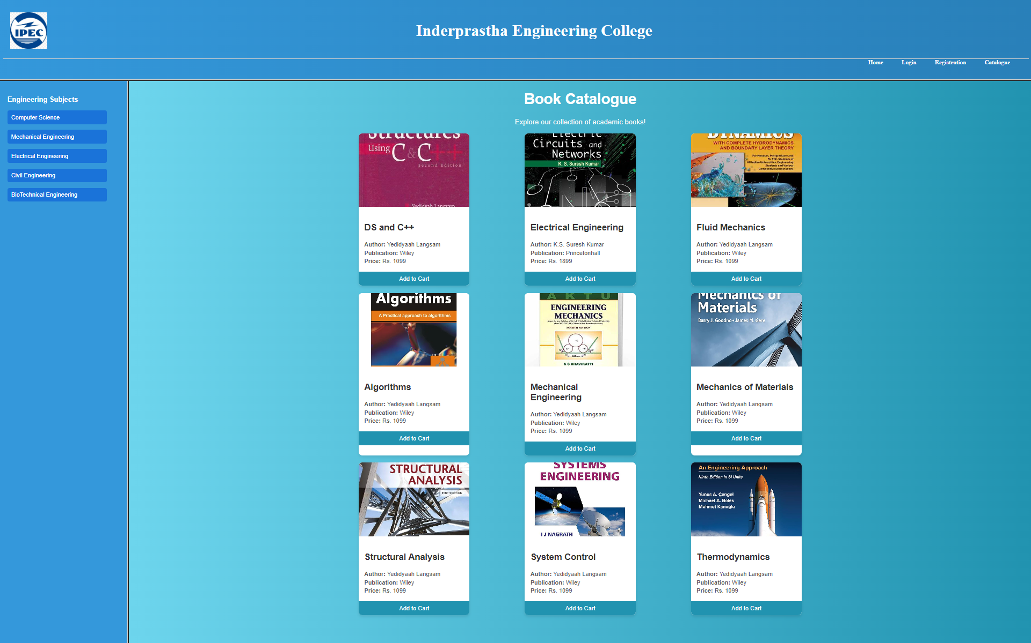

## 

## EXPERIMENT 6:- MAKE A REGISTRATION PAGE FOR COLLEGE WEBSITE.

Date:- 15/10/24

### Source Code:--

Registration.html

<!DOCTYPE html>

<html lang="en">

<head>

<meta charset="UTF-8">

<meta name="viewport" content="width=device-width, initial-scale=1.0">

<title>Registration Page</title>

<style>

body {

background-color: #2980b9;

font-family: Arial, sans-serif;

font-size: 16px;

display: flex;

justify-content: center;

align-items: center;

height: 100vh;

margin: 0;

}

.button-container input[type="submit"] {

background-color: #4CAF50; /* green */

color: #fff;

}

.button-container input[type="reset"] {

background-color: #f44336; /* red */

color: #fff;

}

.form-container {

background-color: #5dc0fd;

padding: 20px;

border: 2px solid #333;

border-radius: 8px;

width: 50%;

box-shadow: 0 0 10px rgba(0, 0, 0, 0.1);

}

h2 {

text-align: center;

color: #333;

margin-bottom: 20px;

}

form {

display: flex;

flex-direction: column;

gap: 15px;

}

label {

font-weight: bold;

}

input[type="text"],

input[type="email"],

input[type="number"],

input[type="password"],

select,

textarea {

width: 100%;

padding: 10px;

border: 1px solid #2980b9;

border-radius: 4px;

}

input[type="radio"],

input[type="checkbox"] {

margin-right: 10px;

}

button {

background-color: #4CAF50;

color: white;

border: none;

padding: 10px 20px;

border-radius: 5px;

cursor: pointer;

}

.button-container {

display: flex;

justify-content: space-between;

}

</style>

</head>

<body>

<div class="form-container">

<h2>Registration Form</h2>

<form action="#" method="post">

<div>

<label for="firstName">First Name:</label>

<input type="text" id="firstName" name="firstName" required>

</div>

<div>

<label for="lastName">Last Name:</label>

<input type="text" id="lastName" name="lastName">

</div>

<div>

<label for="dob">Date of Birth:</label>

<input type="date" id="dob" name="dob">

</div>

<div>

<label for="gender">Gender:</label>

<input type="radio" id="male" name="gender" value="male"> Male

<input type="radio" id="female" name="gender" value="female"> Female

<input type="radio" id="other" name="gender" value="other"> Other

</div>

<div>

<label for="email">Email:</label>

<input type="email" id="email" name="email" required>

</div>

<div>

<label for="mobile">Mobile Number:</label>

<input type="tel" id="mobile" name="mobile" required>

</div>

<div>

<label for="address">Address:</label>

<textarea id="address" name="address"></textarea>

</div>

<div>

<label for="course">Course:</label>

<select id="course" name="course">

<option value="B.Tech.">B.Tech.</option>

<option value="B.B.A">B.B.A</option>

<option value="B.Sc.">B.Sc.</option>

<option value="M.C.A">M.C.A</option>

</select>

</div>

<div>

<label for="board">Board:</label>

<select id="board" name="board">

<option value="C.B.S.E">C.B.S.E.</option>

<option value="I.C.S.E.">I.C.S.E.</option>

<option value="State Board">State Board</option>

</select>

</div>

<div>

<label for="marks">Marks in Percentage:</label>

<input type="number" id="marks" name="marks">

</div>

<div>

<label for="category">Category:</label>

<input type="radio" id="general" name="category" value="General"> General

<input type="radio" id="sc" name="category" value="SC"> SC

<input type="radio" id="st" name="category" value="ST"> ST

<input type="radio" id="obc" name="category" value="OBC"> OBC

<input type="radio" id="general-ews" name="category" value="General-EWS"> General-EWS

</div>

<div>

<label>Sports/Co-Curricular Activities:</label><br>

<input type="checkbox" name="cricket" value="Cricket"> Cricket

<input type="checkbox" name="football" value="Football"> Football

<input type="checkbox" name="badminton" value="Badminton"> Badminton

<input type="checkbox" name="basketball" value="Basketball"> Basketball

<input type="checkbox" name="tableTennis" value="Table Tennis"> Table Tennis

<input type="checkbox" name="chess" value="Chess"> Chess

<input type="checkbox" name="khoKho" value="Kho-Kho"> Kho-Kho

<input type="checkbox" name="kabaddi" value="Kabaddi"> Kabaddi

</div>

<div>

<label for="markSheet">12th Mark Sheet:</label>

<input type="file" id="markSheet" name="markSheet">

</div>

<div>

<label for="password">Password:</label>

<input type="password" id="password" name="password">

</div>

<div class="button-container">

<input type="submit" value="Submit">

<input type="reset" value="Reset">

</div>

</form>

</div>

</body>

</html>

### Output:-

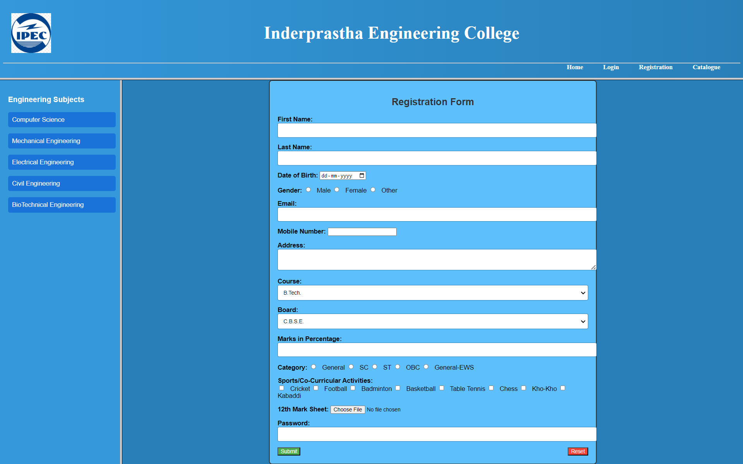

## EXPERIMENT 7:- USE OF CSS SELECTOR.

Date:- 05/11/24

### Source Code:--

Main.html

<!DOCTYPE html>

<html lang="en">

<head>

<meta charset="UTF-8">

<meta name="viewport" content="width=device-width, initial-scale=1.0">

<title>Task 4- Web Page</title>

<link rel="stylesheet" href="task4.css">

</head>

<body class="Bm">

<hr color="black" size="3">

<h1 class="Head" id="idk">

<a href="task4_home.html">HOME</a> &emsp;&emsp;&emsp;&emsp; <a href="task4_about.html">ABOUT</a> &emsp;&emsp;&emsp;&emsp; <a href="task4_contact.html">CONTACT</a>

</h1>

<hr color="black" size="3" id=""idk>

<p class="A">

Lorem ipsum dolor sit amet consectetur, adipisicing elit.

Lorem ipsum dolor sit amet consectetur, adipisicing elit.

<br>

Lorem ipsum dolor sit amet consectetur, adipisicing elit.

Lorem ipsum dolor sit amet consectetur, adipisicing elit.

</p>

<p class="B">

Lorem ipsum dolor sit amet consectetur adipisicing elit.

Lorem ipsum dolor sit amet consectetur, adipisicing elit.

Lorem ipsum dolor sit amet consectetur, adipisicing elit.

<br>

Lorem ipsum dolor sit amet consectetur, adipisicing elit.

Lorem ipsum dolor sit amet consectetur, adipisicing elit.

</p>

</body>

</html>

Home.html

<!DOCTYPE html>

<html lang="en">

<head>

<meta charset="UTF-8">

<meta name="viewport" content="width=device-width, initial-scale=1.0">

<title>Home Page</title>

<link rel="stylesheet" href="task4.css">

</head>

<body class="Bh">

<h1 class="Head" id="idk">

HOME

</h1>

<hr color="black" size="3" id=""idk>

<p class="A">

This is Home Page

</p>

<p>

Lorem ipsum dolor sit amet consectetur adipisicing elit. Sint sed pariatur id quae rem architecto eveniet, obcaecati error veritatis aliquam laudantium, cumque eum perferendis aperiam nesciunt tempore sequi unde. Minima.

</p>

</body>

</html>

About.html

<!DOCTYPE html>

<html lang="en">

<head>

<meta charset="UTF-8">

<meta name="viewport" content="width=device-width, initial-scale=1.0">

<title>About Section</title>

<link rel="stylesheet" href="task4.css">

</head>

<body class="Ba">

<h1 class="Head" id="idk">

ABOUT ME

</h1>

<hr color="black" size="3" id=""idk>

<p class="A">

This is About Section

</p>

<p>Lorem ipsum dolor sit amet consectetur adipisicing elit. Harum maxime nisi deserunt repellat nemo quam molestias vero? Similique quo ea eveniet enim, saepe, architecto minus quaerat sapiente provident aut voluptatem.</p>

</body>

</html>

Contact.html

<!DOCTYPE html>

<html lang="en">

<head>

<meta charset="UTF-8">

<meta name="viewport" content="width=device-width, initial-scale=1.0">

<title>Contact</title>

<link rel="stylesheet" href="task4.css">

</head>

<body class="Bc">

<h1 class="Head" id="idk">

CONTACT

</h1>

<hr color="black" size="3" id=""idk>

<p class="A">

This is my Contact

</p>

<p>

Lorem ipsum dolor sit amet consectetur adipisicing elit. Sint sed pariatur id quae rem architecto eveniet, obcaecati error veritatis aliquam laudantium, cumque eum perferendis aperiam nesciunt tempore sequi unde. Minima.

</p>

</body>

</html>

Experiment07.css

.A

{

text-align: center;

color: red;

font-family: 'Lucida Sans', 'Lucida Sans Regular', 'Lucida Grande', 'Lucida Sans Unicode', Geneva, Verdana, sans-serif;

}

#idk

{

text-align: center;

}

.Ba

{

background-image: url("bg1.jpg");

background-repeat: no-repeat;

background-size: cover;

background-attachment: fixed;

font-family:Arial, Helvetica, sans-serif;

}

.Bc

{

background-image: url("bg2.jpg");

background-repeat: no-repeat;

background-size: cover;

background-attachment: fixed;

font-family: 'Trebuchet MS', 'Lucida Sans Unicode', 'Lucida Grande', 'Lucida Sans', Arial, sans-serif;

}

.Bh

{

background-image: url("bg3.jpg");

background-repeat: no-repeat;

background-size: cover;

background-attachment: fixed;

font-family: 'Gill Sans', 'Gill Sans MT', Calibri, 'Trebuchet MS', sans-serif;

}

.Bm

{

background-image: url("bg4.jpg");

background-repeat: no-repeat;

background-size: cover;

background-attachment: fixed;

font-family: 'Lucida Sans', 'Lucida Sans Regular', 'Lucida Grande', 'Lucida Sans Unicode', Geneva, Verdana, sans-serif;

}

a {

color:yellow;

}

### 

### Output:-

Main Window

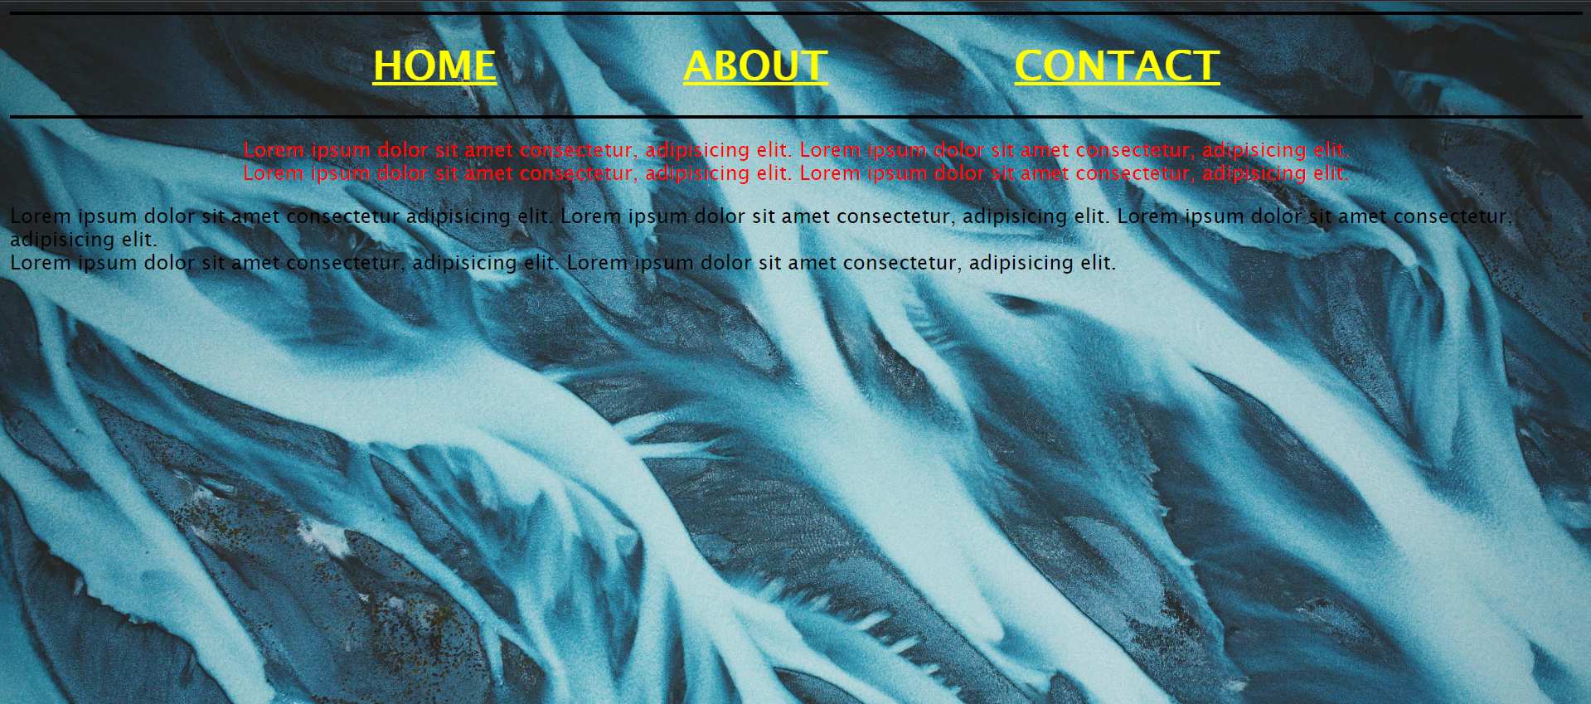

Home Window

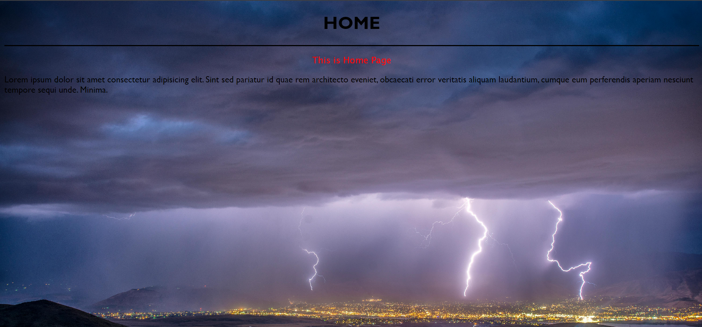

About Window

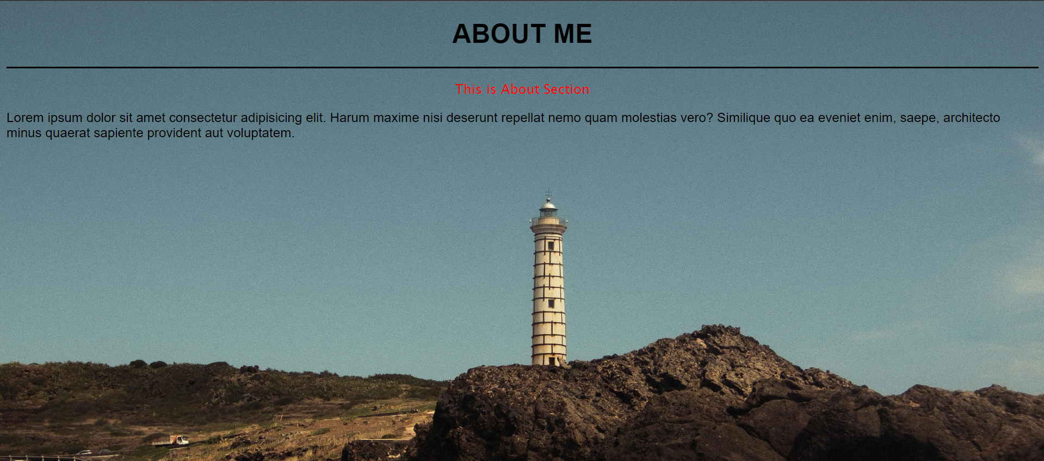

Contact Window

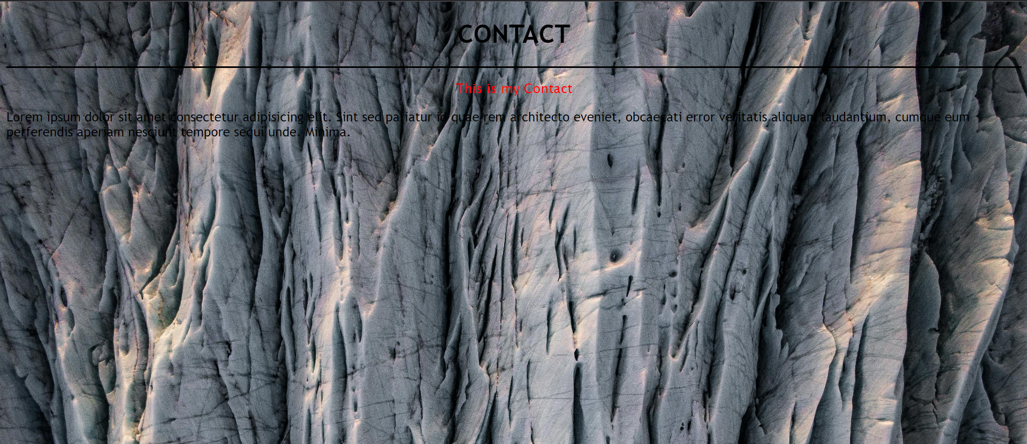

## EXPERIMENT 8:- USE OF BACKGROUND REPEAT PROPERTY.

Date:- 12/11/24

### Source Code:--

space.html

<!DOCTYPE html>

<html lang="en">

<head>

<meta charset="UTF-8">

<meta name="viewport" content="width=device-width, initial-scale=1.0">

<title>Lab 5 Task 1</title>

<style>

body {

background-image: url('1.jpg');

background-repeat: space;

background-size: contain; /* Adjusts the size of the image */

background-position: top; /* Aligns the image at the top */

height: 10vh;

margin: 0; /* Removes default margin around the body */

}

.center-box {

width: 300px;

background-color: #f0f0f0;

border: 1px solid #ccc;

padding: 20px;

position: absolute;

top: 50%;

left: 50%;

transform: translate(-50%, -50%);

}

</style>

</head>

<body>

<div class="center-box">

<h2>Hello, World!</h2>

<p>This is a centered box for space.html.</p>

</div>

</body>

</html>

no_repeat.html

<!DOCTYPE html>

<html lang="en">

<head>

<meta charset="UTF-8">

<meta name="viewport" content="width=device-width, initial-scale=1.0">

<title>Lab 5</title>

<style>

body {

background-image: url('1.jpg');

background-repeat:no-repeat;

background-size: contain; /* Adjusts the size of the image */

background-position: top; /* Aligns the image at the top */

height: 10vh;

margin: 0; /* Removes default margin around the body */

}

.center-box {

width: 300px;

background-color: #f0f0f0;

border: 1px solid #ccc;

padding: 20px;

position: absolute;

top: 50%;

left: 50%;

transform: translate(-50%, -50%);

}

</style>

</head>

<body>

<div class="center-box">

<h2>Hello, World!</h2>

<p>This is a centered box for no_repeat.html.</p>

</div>

</body>

</html>

repeat-x.html

<!DOCTYPE html>

<html lang="en">

<head>

<meta charset="UTF-8">

<meta name="viewport" content="width=device-width, initial-scale=1.0">

<title>Lab 5</title>

<style>

body {

background-image: url('1.jpg');

background-repeat: repeat-x;

background-size: contain; /* Adjusts the size of the image */

background-position: top; /* Aligns the image at the top */

height: 10vh;

margin: 0; /* Removes default margin around the body */

}

.center-box {

width: 300px;

background-color: #f0f0f0;

border: 1px solid #ccc;

padding: 20px;

position: absolute;

top: 50%;

left: 50%;

transform: translate(-50%, -50%);

}

</style>

</head>

<body>

<div class="center-box">

<h2>Hello, World!</h2>

<p>This is a centered box for repeat-x.html.</p>

</div>

</body>

</html>

repeat-y.html

<!DOCTYPE html>

<html lang="en">

<head>

<meta charset="UTF-8">

<meta name="viewport" content="width=device-width, initial-scale=1.0">

<title>Lab 5</title>

<style>

body {

background-image: url('1.jpg');

background-repeat: repeat-y;

background-size: contain; /* Adjusts the size of the image */

background-position: top; /* Aligns the image at the top */

height: 10vh;

margin: 0; /* Removes default margin around the body */

}

.center-box {

width: 300px;

background-color: #f0f0f0;

border: 1px solid #ccc;

padding: 20px;

position: absolute;

top: 50%;

left: 50%;

transform: translate(-50%, -50%);

}

</style>

</head>

<body>

<div class="center-box">

<h2>Hello, World!</h2>

<p>This is a centered box for repeat-y.html.</p>

</div>

</body>

</html>

round.html

<!DOCTYPE html>

<html lang="en">

<head>

<meta charset="UTF-8">

<meta name="viewport" content="width=device-width, initial-scale=1.0">

<title>Lab 5</title>

<style>

body {

background-image: url('1.jpg');

background-repeat: round;

background-size: contain; /* Adjusts the size of the image */

background-position: top; /* Aligns the image at the top */

height: 10vh;

margin: 0; /* Removes default margin around the body */

}

.center-box {

width: 300px;

background-color: #f0f0f0;

border: 1px solid #ccc;

padding: 20px;

position: absolute;

top: 50%;

left: 50%;

transform: translate(-50%, -50%);

}

</style>

</head>

<body>

<div class="center-box">

<h2>Hello, World!</h2>

<p>This is a centered box for round.html.</p>

</div>

</body>

</html>

### Output:-

space.html

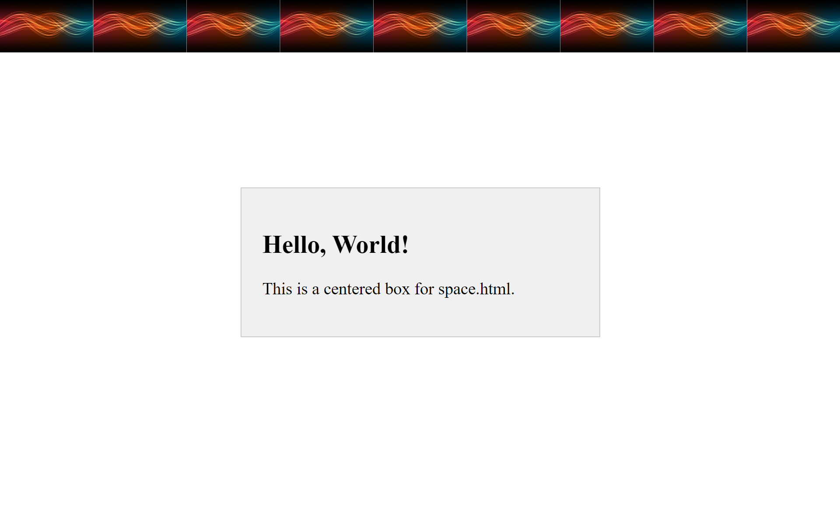

no-repeat.html

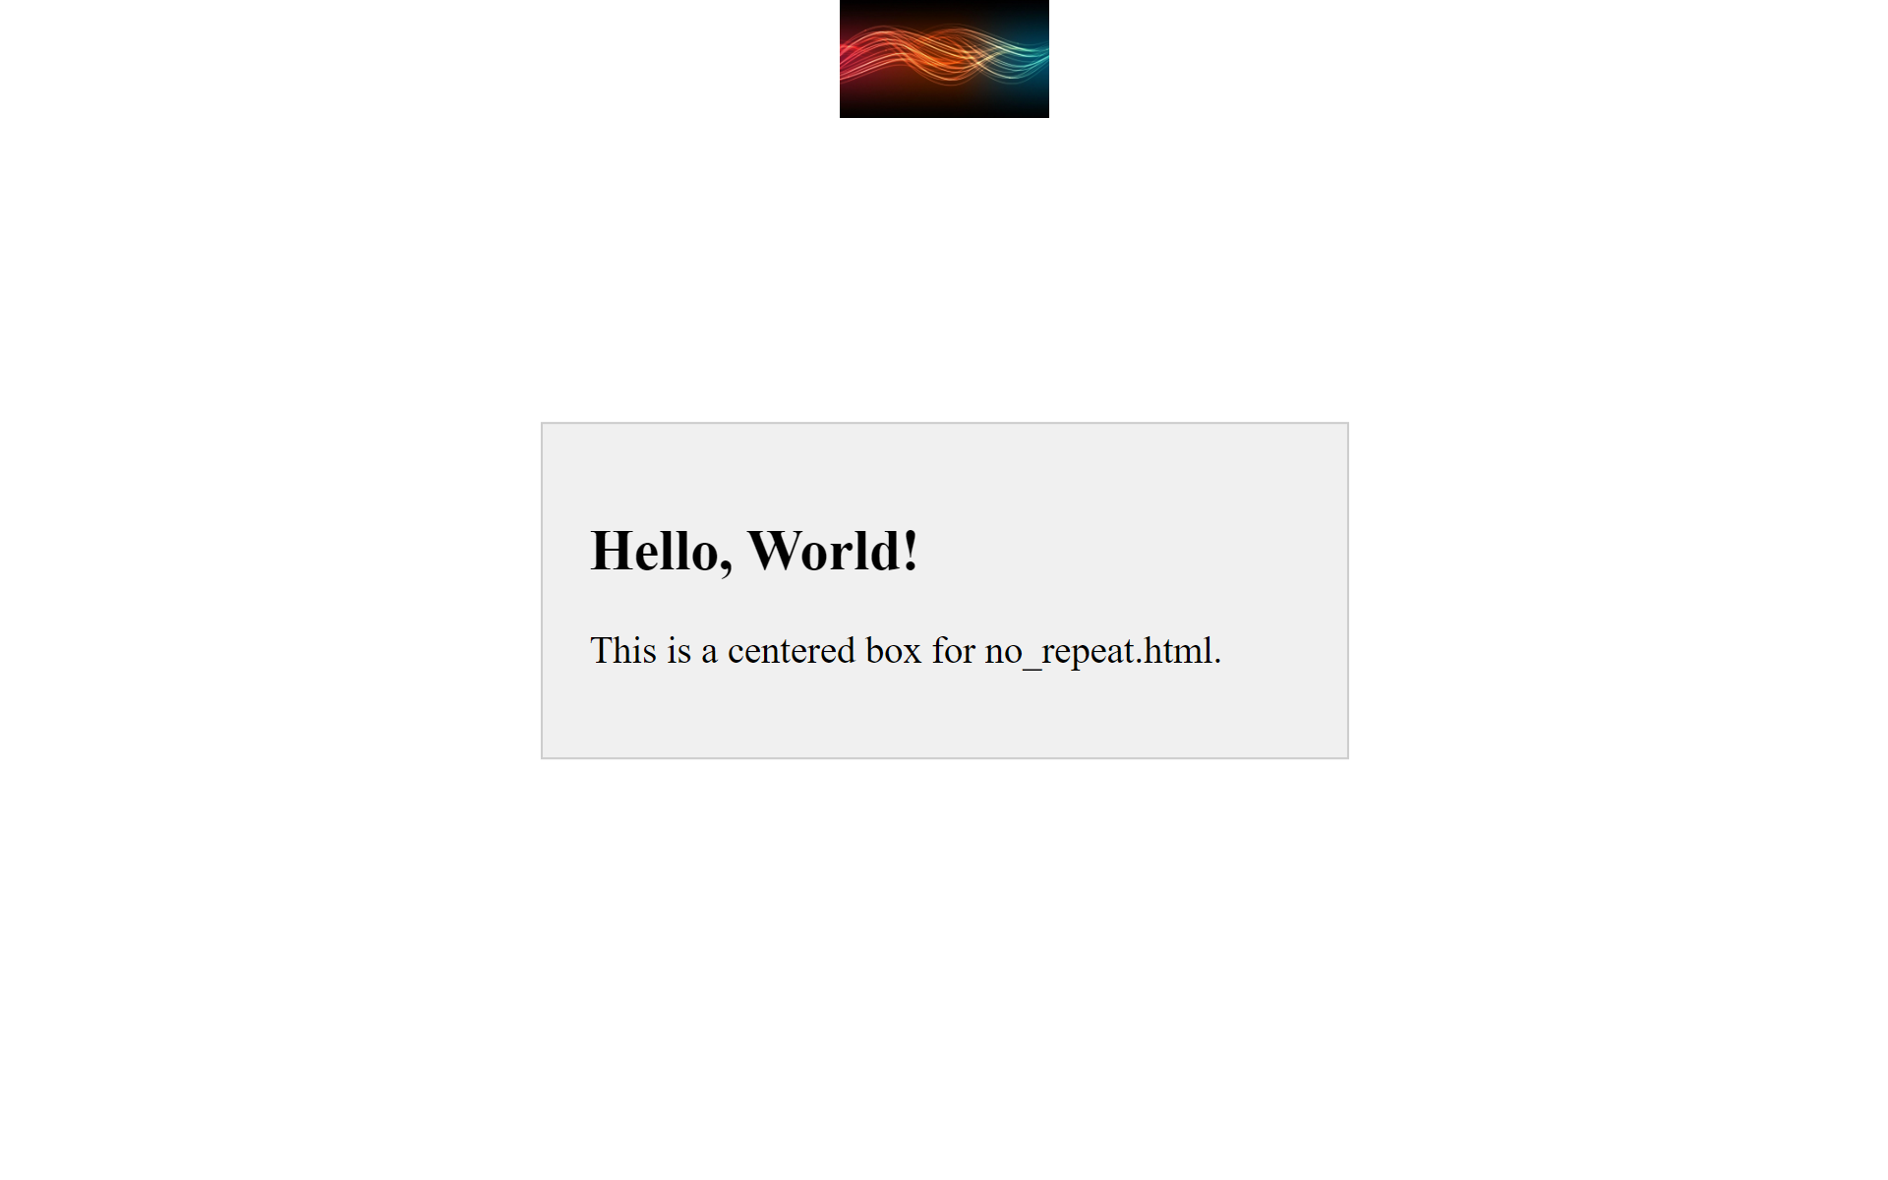

repeat-x.html

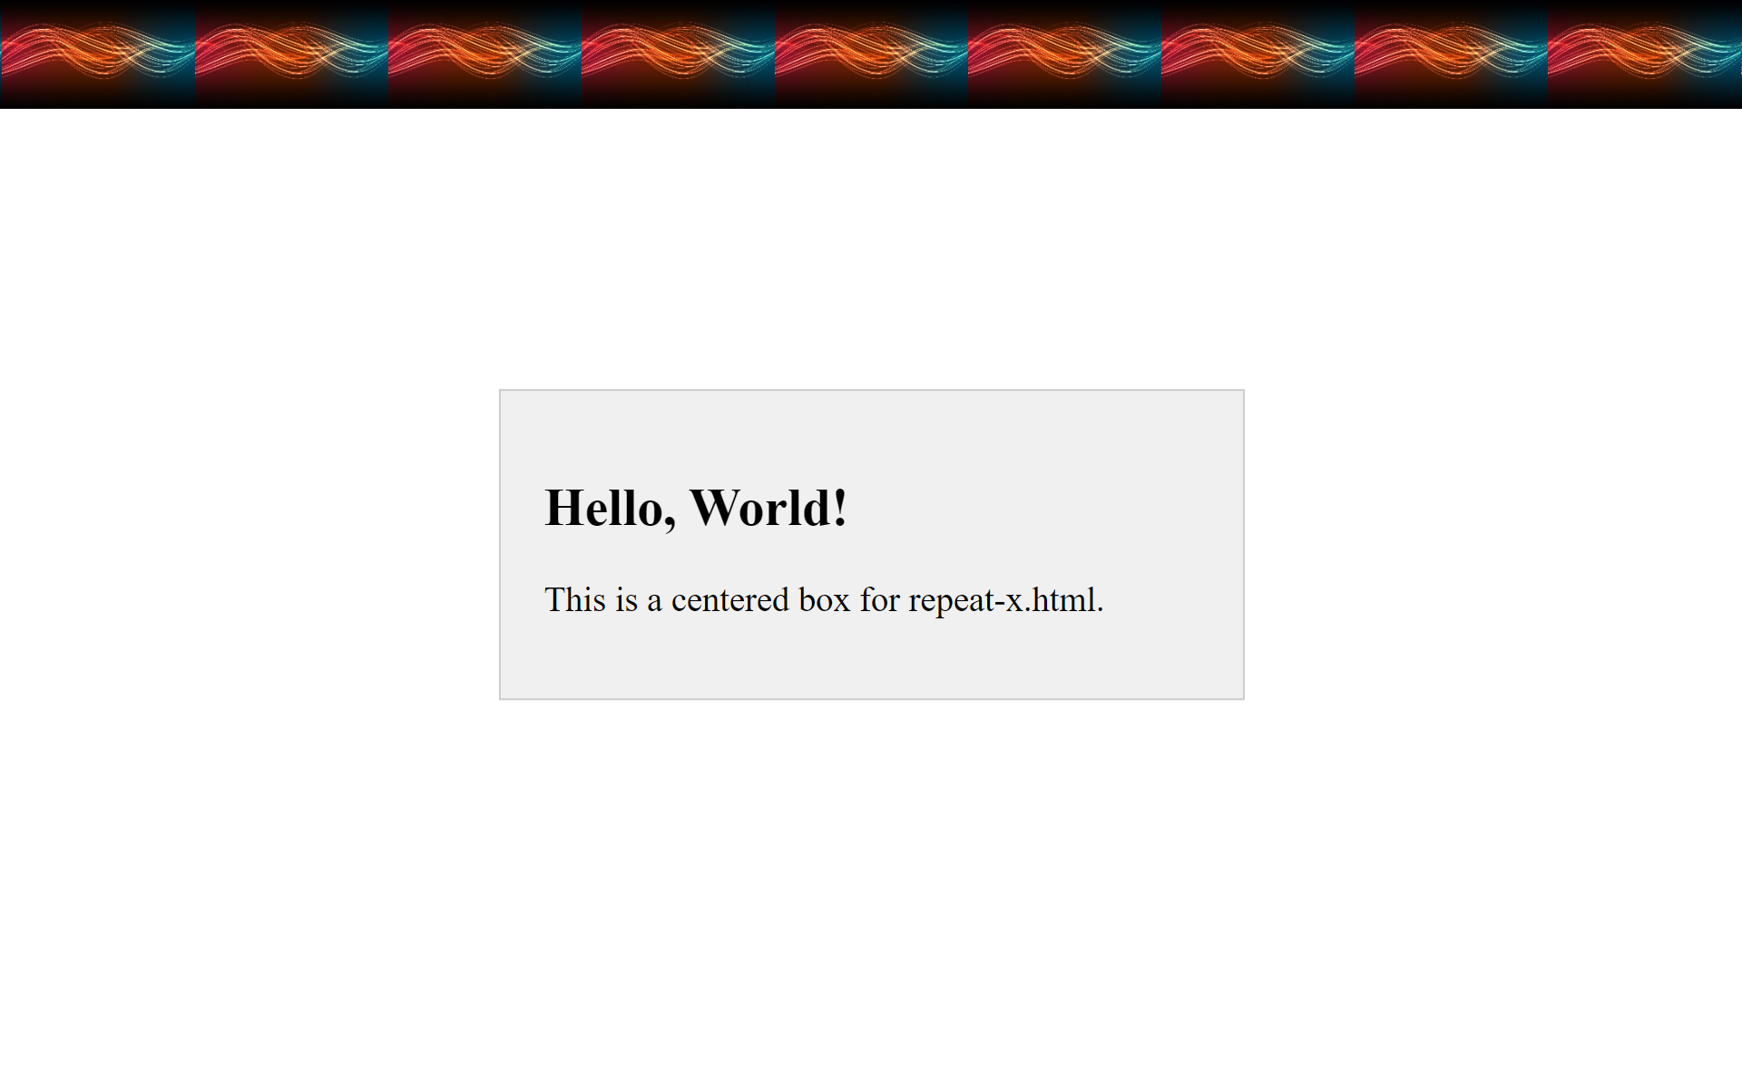

repeat-y.html

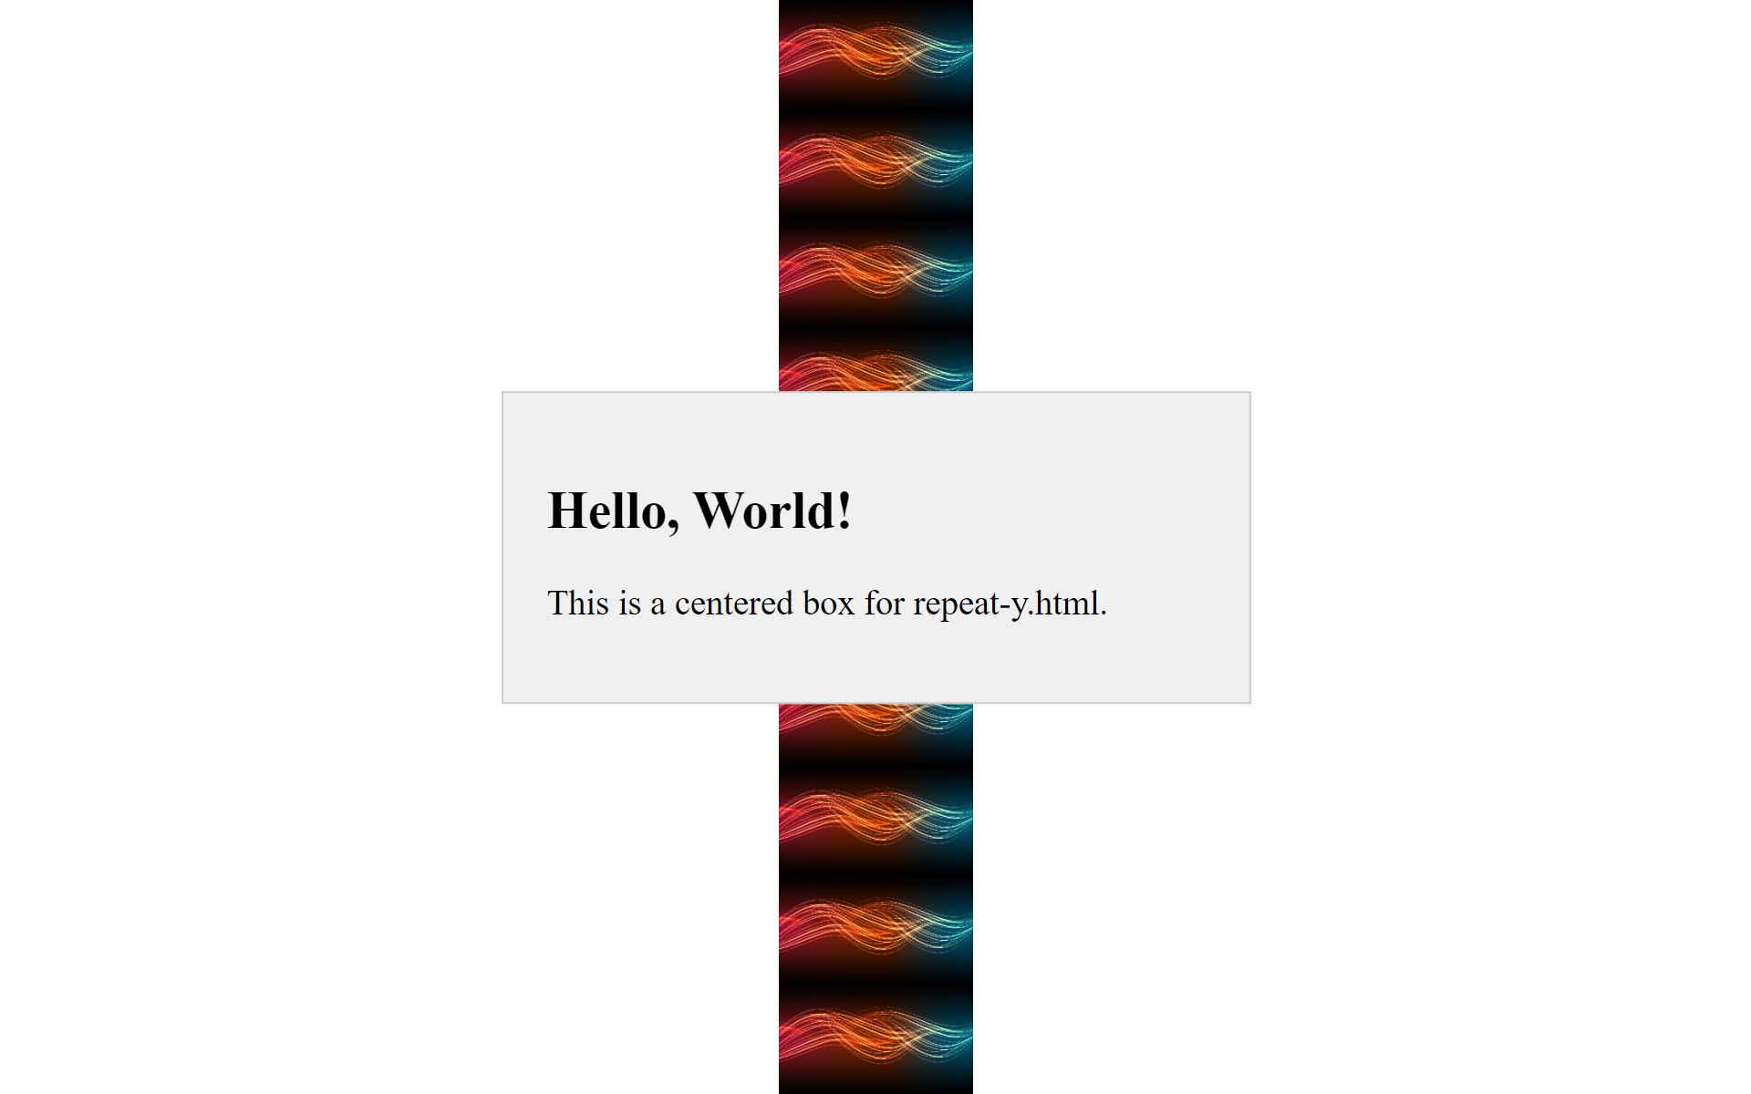

round.html

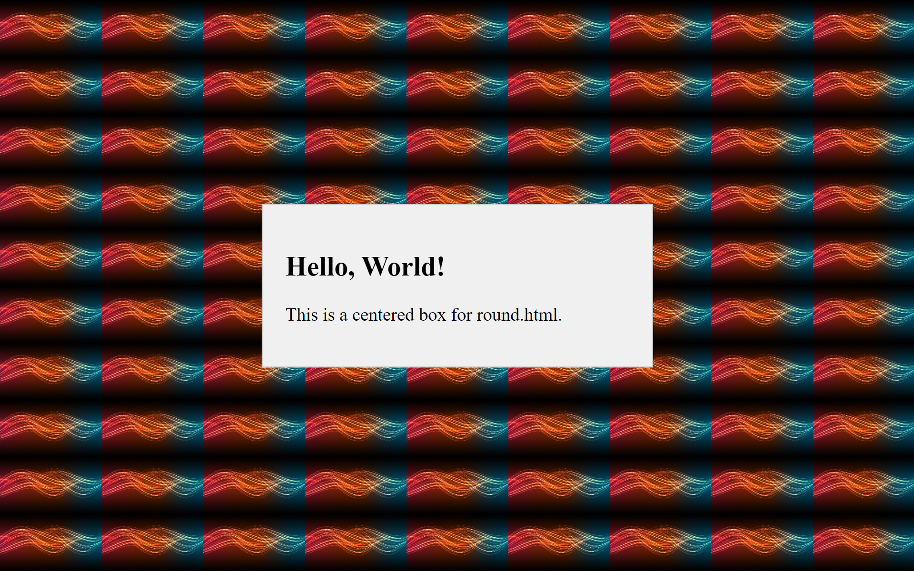

## EXPERIMENT 9:- USE OF CSS IN LINKS .

Date:- 12/11/24

### Source Code:--

link.html

<!DOCTYPE html>

<html>

<head>

<title>Styled Links</title>

<link rel="stylesheet" href="style.css">

</head>

<body>

<h1>Styled Links</h1>

<p>These links will be styled using CSS classes.</p>

<div class="link-container">

<a href="https://www.Google.com">Google Link</a>

<a href="https://www.Youtube.com">Youtube Link</a>

<a href="https://www.Geekforgeeks.com">GFG Link</a>

</div>

</body>

</html>

style.css

body {

font-family: Arial, sans-serif;

margin: 0;

padding: 20px;

background-color: #f0f0f0;

}

h1{

text-align: center;

color: red;

}

p{

color: green;

}

.link-container {

display: flex;

flex-wrap: wrap;

justify-content: space-around;

}

a {

text-decoration: none;

padding: 10px 20px;

border-radius: 5px;

margin: 10px;

}

a:link {

color: pink;

background-color: maroon;

}

a:visited {

color: blue;

background-color: pink;

}

a:hover {

color: white;

background-color: #3498db;

}

a:active {

color: yellow;

background-color: #f0f0f0;

}

### Output:-

